Github ca1

Urshita Parmar

Reg no. 12303424

**Task 1: Working with Git – File States, Project Section, Workflow**

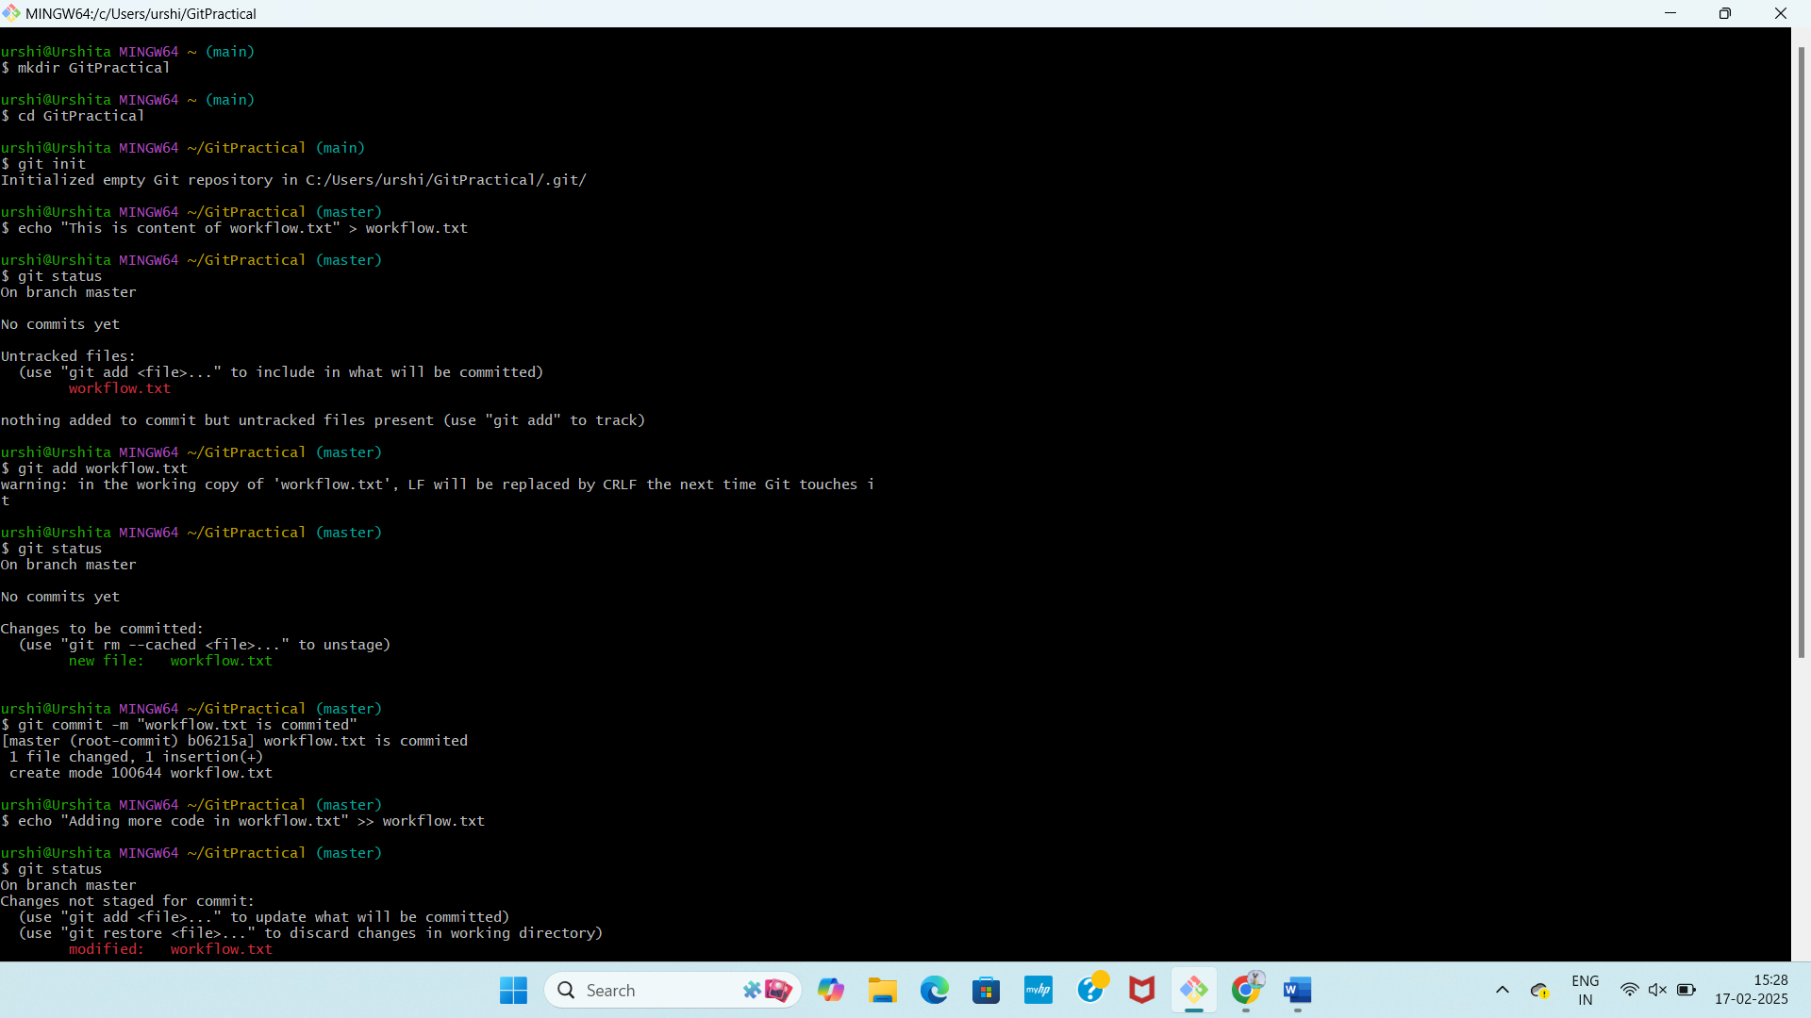

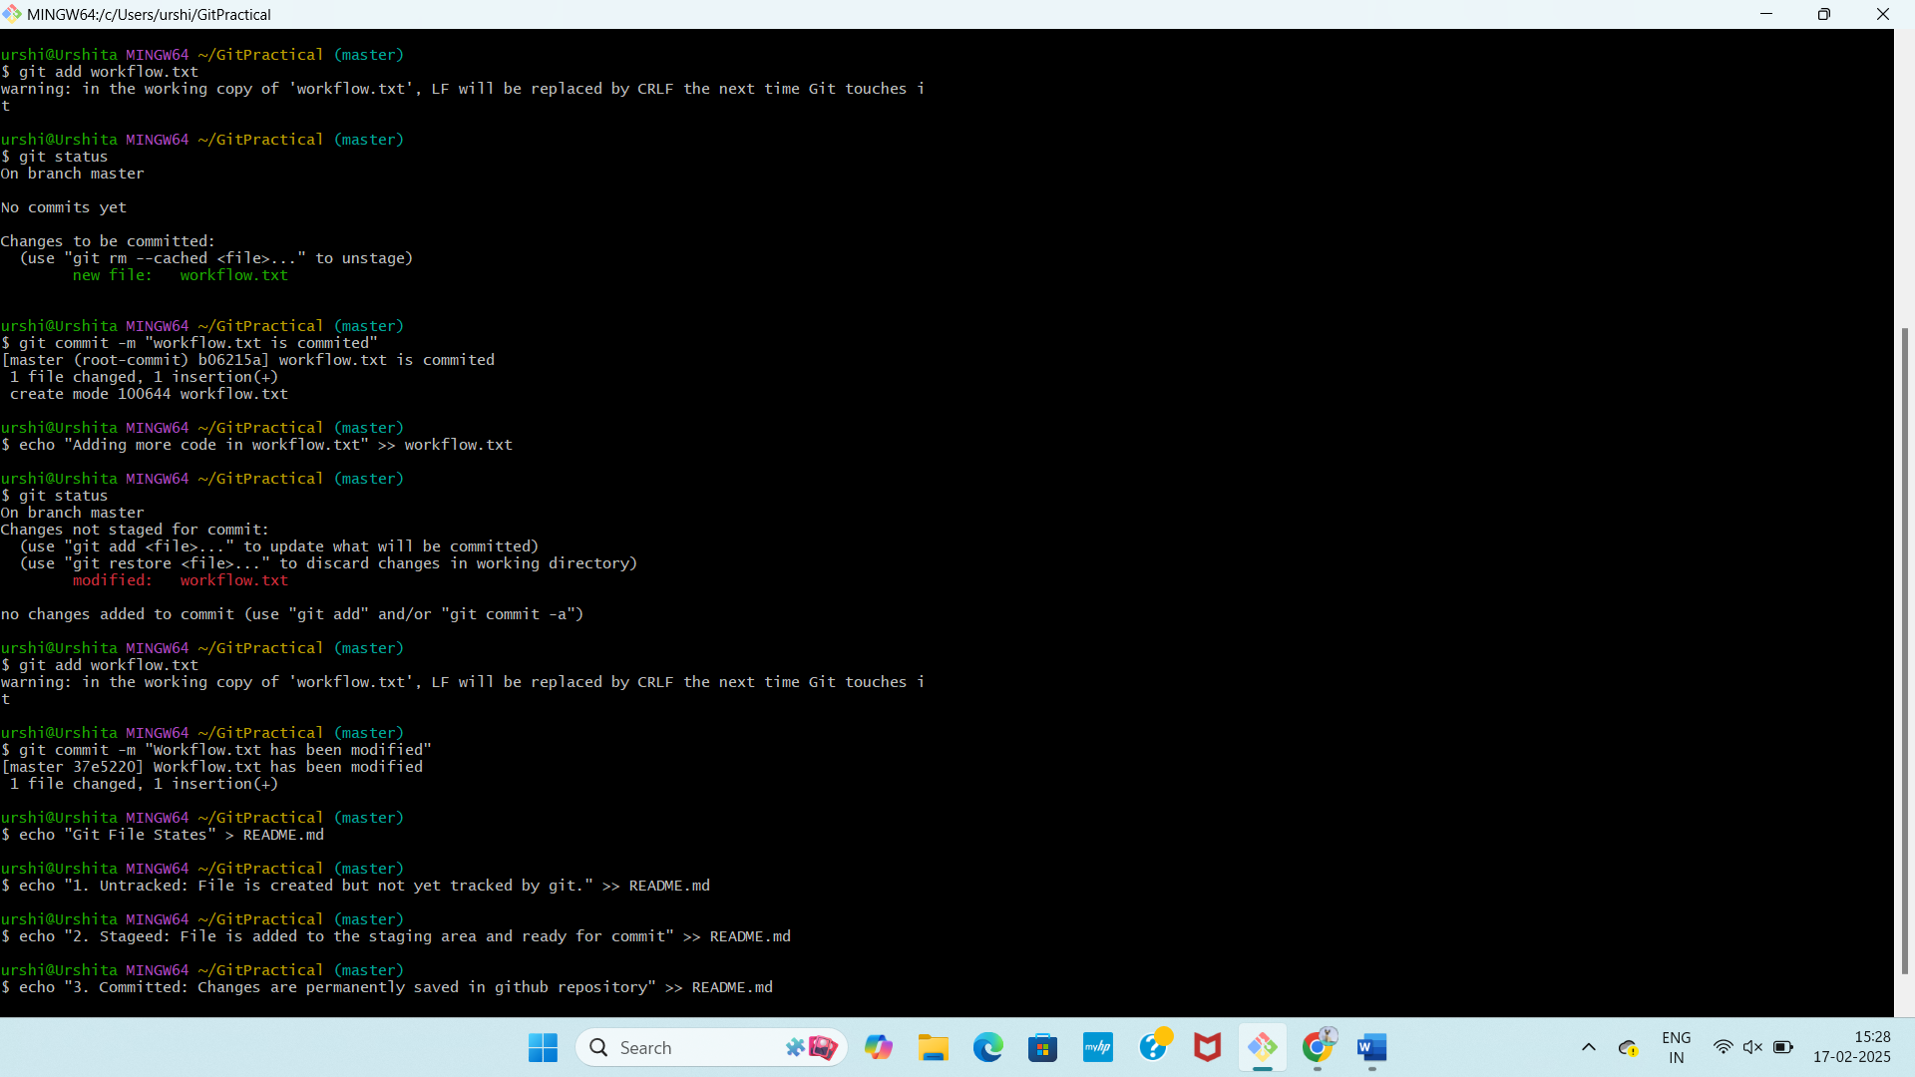

**Task 2: Working with Git History (15 Marks)**



